Graphing Homework 6
Inflationary Gap and Self Adjustment
Show how self adjustment will correct the short run equilibrium in the LR. Label the points A and B and C if necessary.

Draw the following graphs in each of the boxes.
Inflationary Gap and Fiscal Policy
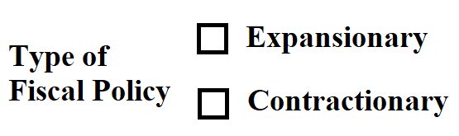Show how fiscal policy will be used to correct the short run equilibrium. Label the points A and B and C if necessary.

Inflationary gap – the PL has ________.
Result: Wages in SR ________. Wages in LR ______ and SRAS will _________.

Inflationary Gap

Self adjustment shifts the __________ (SRAS/AD) and happens in the ___________ (long run/short run) and happens _______ (with/without) the government.
Fiscal Policy shifts the __________ (SRAS/AD) and happens in the ___________ (long run/short run) and happens _______ (with/without) the government.

Recessionary Gap

Recessionary Gap and Fiscal Policy
Show how fiscal policy will be used to correct the short run equilibrium. Label the points A and B and C if necessary.

Recessionary Gap and Self Adjustment
Show how self adjustment will correct the short run equilibrium in the LR. Label the points A and B and C if necessary.

Recessionary gap – the PL has ________.
Result: Wages in SR ________. Wages in LR ______ and SRAS will _________.

